Display output options

Export from Image window
Images can be exported from the Image window as simple images (which may also show superimposed selected "region" pixels in green) using the menu "File-->Export-->Simple Image-->Save image as PNG". More complex output plots can be exported using the menu "File-->Export-->Image Plot-->Current image as JPEG". The plot options popup provides options for display axes and distance legends, their style and placement, and for the display of a region shape, or cropping to the bounds of that shape. Axes labels can be in relative coordinates (mm from bottom-left corner) or in "absolute" stage coordinates.
NOTE: Use the new JPEG export option as the alternative (PNG) generates files 10x larger. The new JPEG uses the highest quality, so there is no need for PNG.
Click on "Preview" to see it plotted on the screen first, then "OK" to output the full JPEG plot to disk.
You can resize the preview window for the exports to not only give you a larger preview window if desired, but also to give you a better aspect ratio for the plots. This same aspect ratio is then used for the final JPEG file outputs. This way you can make them fill out better (see Demo/MM/analysis/925).
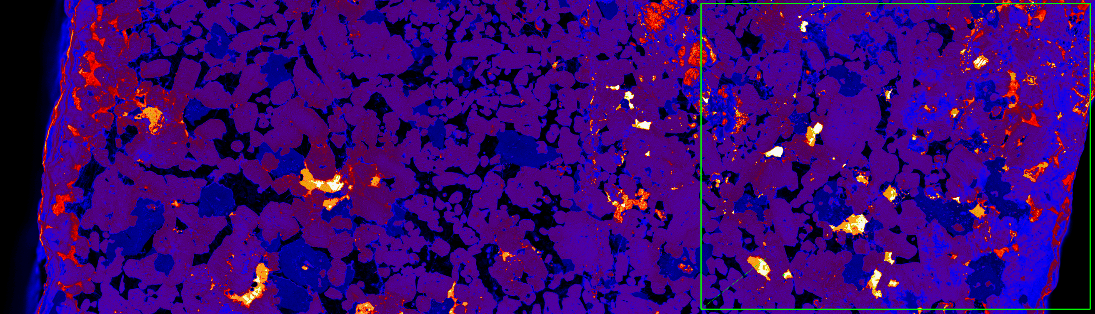
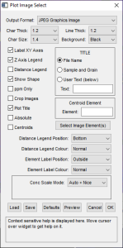
Simple PNG image export showing a region "Box" shape (left), plot export selection popup (right)
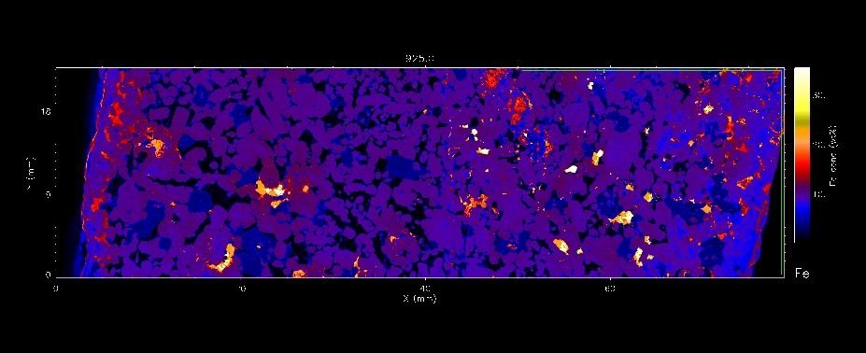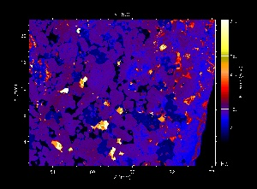
Plot JPEG export of Fe image showing region as "shape" and selected region pixels in green (left), plot JPEG export of Fe cropped to the shape area (right)
The location of hot-spots can be included on the export plot by enabling "Centroids". First, remember to select region #0 before you open the Export Plot window, which shows ALL hot-spots in green on the plot. Then enable "Centroids" and select "Pt" as the "Centroid Element" (must be a single element - will use the centroid X,Y based on this element for each region to position a circle).
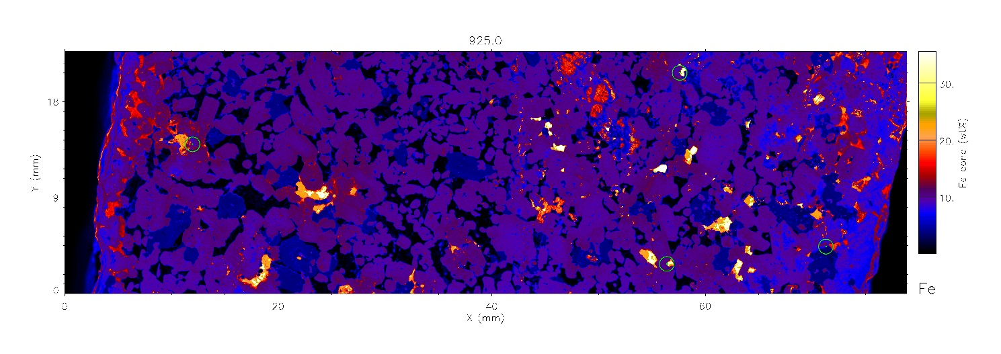
Plot export of Fe on White background, now enabling "Centroids" and selecting centroid Element as "Pt" (now in circles)

Changing the Colour Scheme
The default colour scheme for single element maps can be changed to suit your needs. The linear colour scales such as "B-W Linear" and "Blue/White" can be used to ensure the maps are colourblind friendly.
Change the colour scheme the using the menu "Display-->Colours→Colour Table" and chose a colour table to suit your needs. This will now be the default colour scheme when you open any new files in this session.
The menu "Display-->Colours-->Red Colour Blind-->On" also sets the Blue/White colour map and changes how spectra colour overlays works too.
To export, follow the instructions above in: Export from Image Window.

Export from RGB Image window

RGB Images
Any display on the RGB Window can be saved as a simple JPEG file using the menu "File-->Export-->Simple Image-->Save as JPEG" (avoid using the PNG save option, as it makes files ~10x bigger with little visible improvement in quality as we use the highest quality JPEG settings). This will output the RGB image at the current zoom (which may not show all detail). To get all details, go to full scale first (zoom=0, using "0" button).
Better still, use the RGB "Learn" feature to learn all the RGB images you want output, and to do them all automatically, and at full resolution (zoom=0). For the first RGB combination that you want, use the menu "Learn-->Start" to register the first RGB image. For subsequent ones, use menu "Learn-->Next". Finally, save all these using menu "Learn-->Save". Note that a number of these RGB scripts have been saved already in the top-level "analysis" directory (in MapperMel1). To restore one of these, use menu "Learn-->Restore". Note that no images have been output yet. To output all images at a selected zoom (defaults to full scale, zoom=0), use the menu "Learn-->Execute".
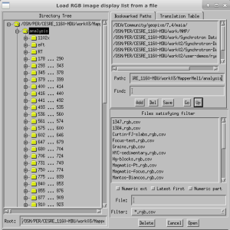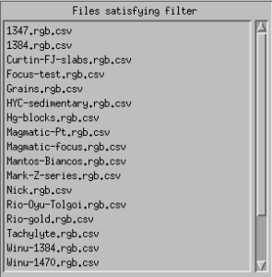
Note that the Learn RGB CSV files are simple text files and can be edited.

RGB Image plots
The RGB image window has similar export options to the Image window plots. Best to use the menu "File-->Export-->Image Plot-->Current image as JPEG" (avoid using the PNG save option, as it makes files ~10x bigger with little visible improvement in quality as we use the highest quality JPEG settings).
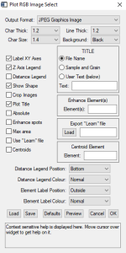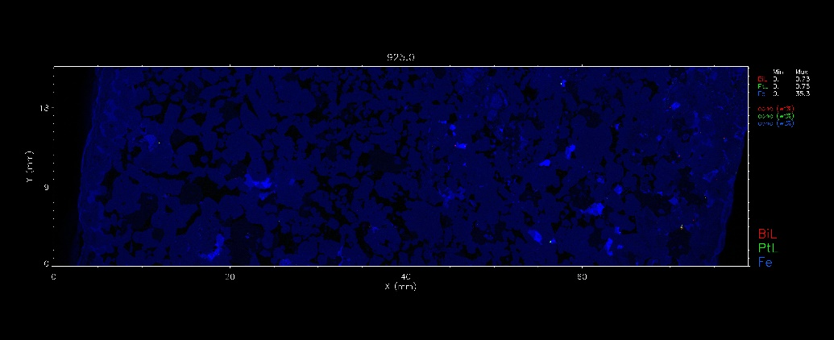
Plot JPEG options popup (left) and Bi Pt Fe RGB image export (right)
Click on "Preview" to see it plotted on the screen first, then "OK" to output the full JPEG plot to disk.
You can resize the preview window for the exports to not only give you a larger preview window if desired, but also to give you a better aspect ratio for the plots. This same aspect ratio is then used for the final JPEG file outputs. This way you can make them fill out better.
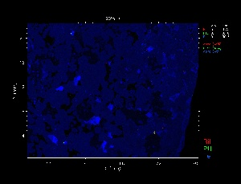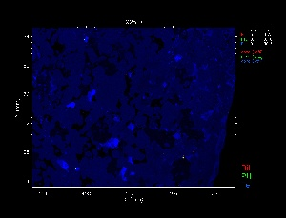
Plot JPEG image export for a cropped region of the Bi Pt Fe RGB image in relative coordinates (left) and absolute stage coordinates (right)

Highlight hotspots on plots
The export can also highlight the location of hotspots using the "Centroids" option for the single element display and the "Enhance" and/or "Centroids" options for the RGB display. "Centroids" will plot a ring around each hotspot (in Green on a single element plot and in White on a RGB plot) as listed in the Image Regions table. Select the element to use its XY centroid coordinates in the "Centroid element" text field. "Enhance" will use a grey-scale Dilate morphological operator to slightly expand selected element features so they remain visible on the RGB display or output plot. You can also select a list of RGB element combinations to plot from a Learn file.

